* The difference between dynamic programming and recursion is that in dynamic programming the smaller sub problems solutions are stored and can be used and reused unlike recursion.
* It is basically dividing the bigger problem into sub-problems.
* 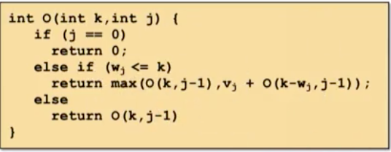
* Running time of the dynamic programming algorithm is exponential depending on the input size. Thus, it works well only on problems sizes where the capacity is small.
* As the capacity (K) increases the size of the array in which the values are stored also increases exponentially. Thus, should be avoided for large problems.
* Main elements of a dynamic program are:
  + The base case.
  + Optimum solution data structure. The dimensionality or type of data structure depends on the solution to be generated.